NEW LOCATION

Raphael’s Furniture Restoration, LLC
Glenbrook Industrial Park Unit #9-101
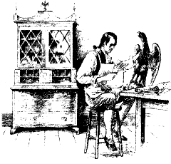
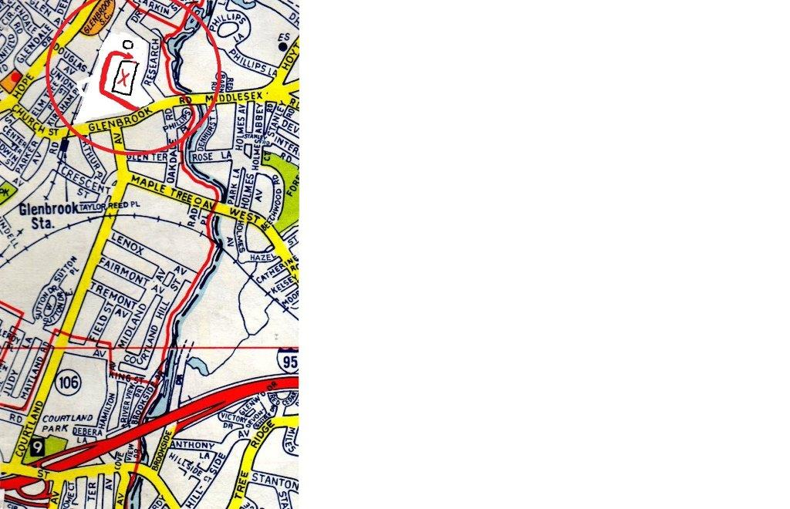
652 Glenbrook Road, Stamford, CT 06906
Raphael’s Furniture Restoration, LLC
ANTIQUE FURNITURE RESTORATION

MARK DEVITO, American Master Craftsman

Glenbrook Industrial Park, Unit #9-101
652 Glenbrook Road, Stamford, CT 06906
(203) 348-3079

Hours: Monday to Thursday 8:00 a.m. - 5:00 p.m.
Friday 8:00 a.m. - 3:00 p.m. Saturday 8:00 a.m. - Noon.

When you enter the Glenbrook Industrial Park, drive around the building clockwise, as shown on the map. You will pass a brick smokestack. An auto detail shop is on the left. Raphael’s is on the right side. You will see our signs.

Interstate 95 North: Take Exit 9 toward US-1/CT-106/ Glenbrook. Turn Left onto Seaside Ave. Turn Left onto
US-1/E Main St/Boston Post Rd. Turn Right onto Courtland Ave/CT-106 (1.1 miles to end). Turn Right onto Glenbrook Rd/CT-106. End at Glenbrook Industrial Park on left.

Interstate 95 South: Take Exit 9 toward US-1/CT-106/ Glenbrook. Turn Right onto US-1/E Main St/Boston Post Rd.
Turn Right onto Courtland Ave/CT-106. Turn Right onto Glenbrook Rd/CT-106 (1.1 miles to end). End at Glenbrook Industrial Park on the left.

Merritt Parkway North: Take the CT-106/Old Stamford Rd/Exit 36. Turn right. Continue to follow CT-106. Turn Right onto Middlesex Rd/CT-106. Continue to follow CT-106. End at Glenbrook Industrial Park on the right.

Merritt Parkway South: Take the CT-106/Old Stamford Rd/Exit 36. Turn right. Continue to follow CT-106. Turn Right onto Middlesex Rd/CT-106. Continue to follow CT-106. End at Glenbrook Industrial Park on the right.
www.raphaelsfurniture.com (203) 348-3079 markdevito@optimum.net
GLENBROOK ROAD
RAPHAEL’S
NORTHEAST UTILITIES
SMOKESTACK

